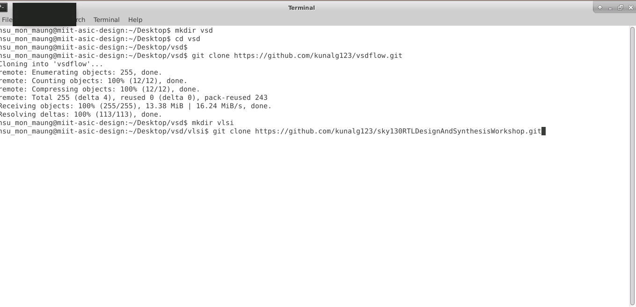

Below screenshot shows the above directory structure inside the vsd upto my_lib directories that was set up through the terminal.

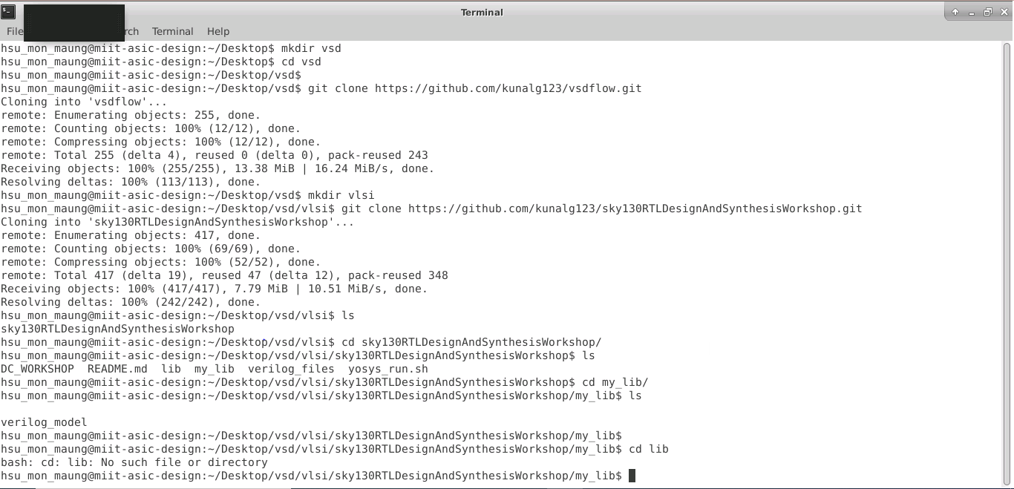

Below screenshot is git clone https://github.com/kunalg123/sky130RTLDesignAndSynthesisWorkshop

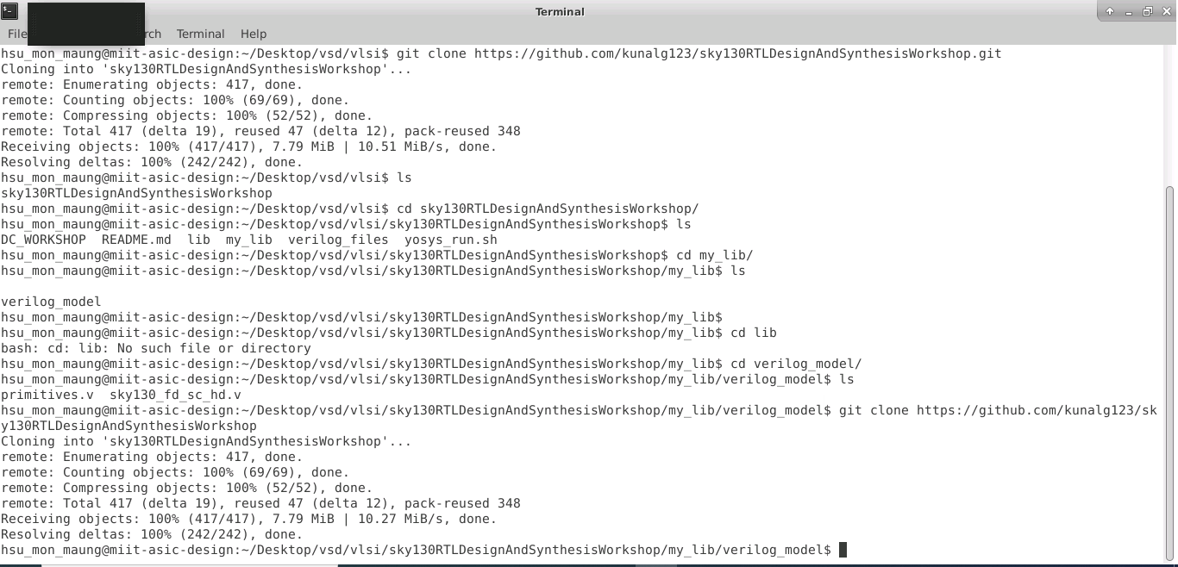

Below screenshot shows directory by cloning the sky130RTLDesignAndSynthesisWorkshop

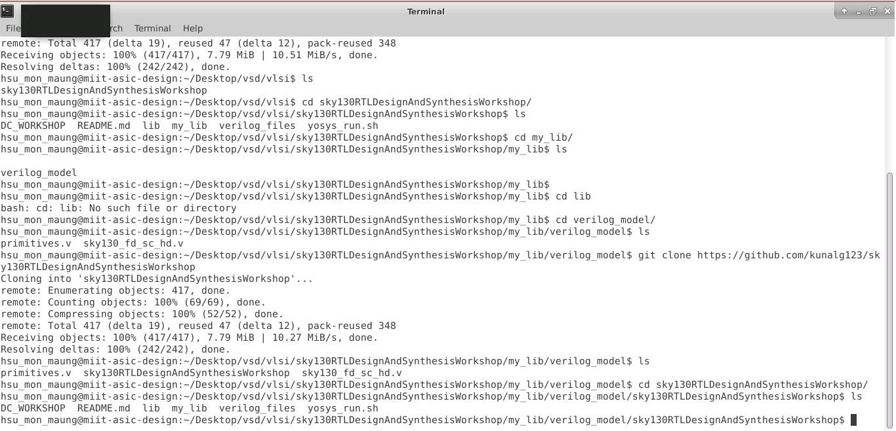

Below screenshot shows the list of verilog files.

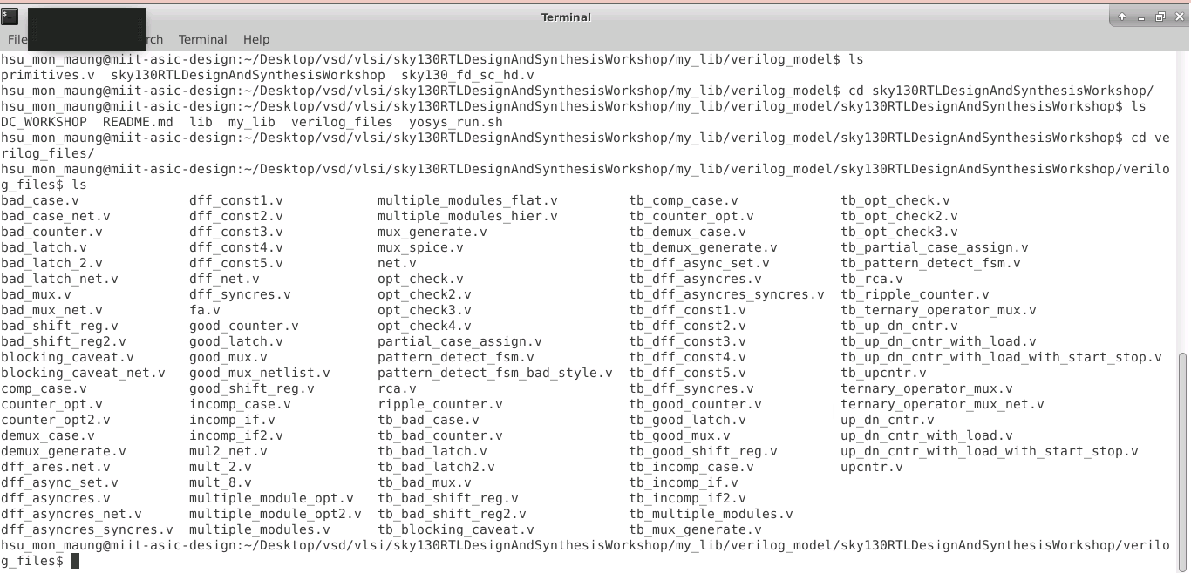

After this command - iverilog good_mux.v tb_good_mux.v, following list of files can be seen

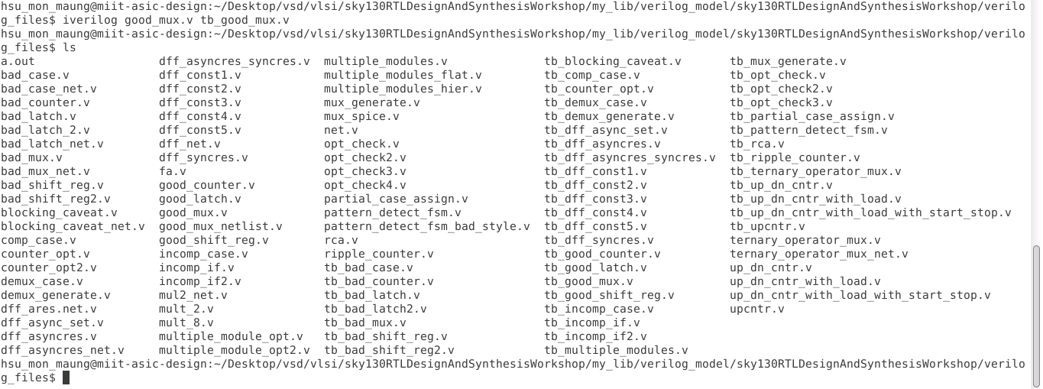

Below screenshot shows dumping the output into a vcd file by ./a.out



Below screenshot is gtkwave window.

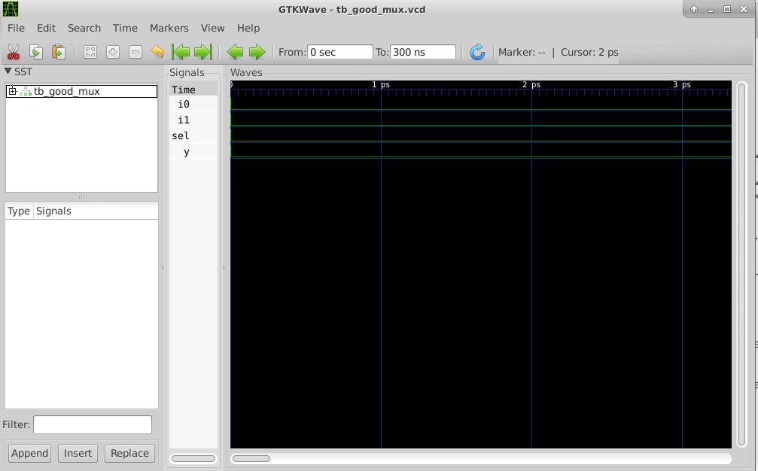

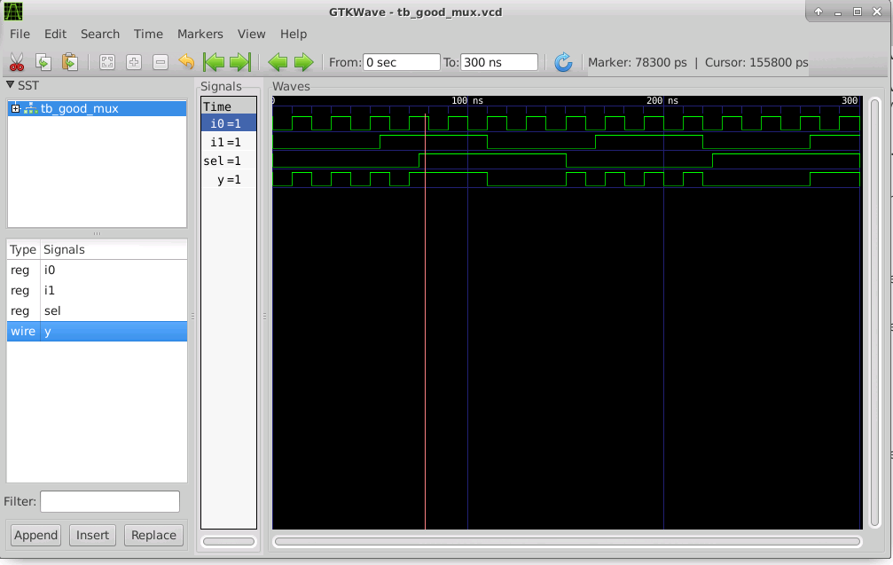

Error : gvim tb_good_mux.v -o good_mux.v

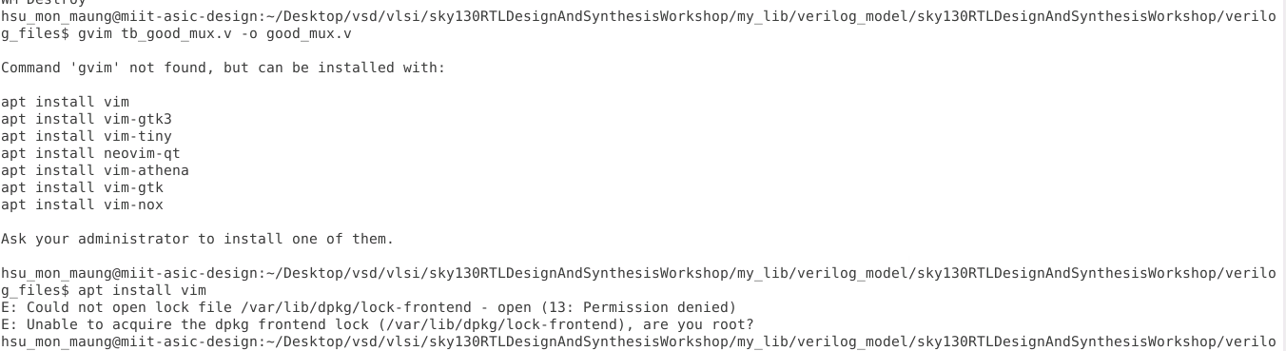

Below screenshot is vim tb_good_mux.v -o good_mux.v

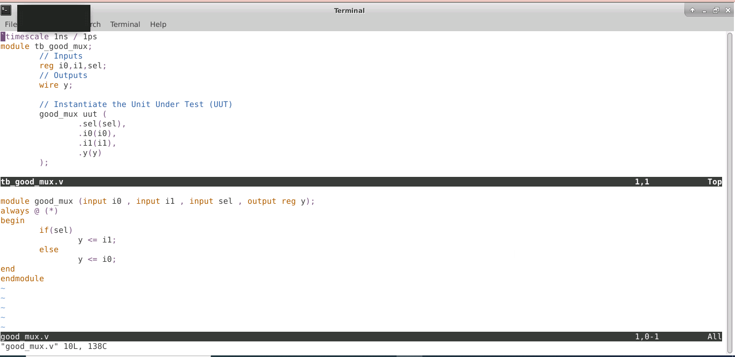

Below screenshot shows after synth -top good_mux

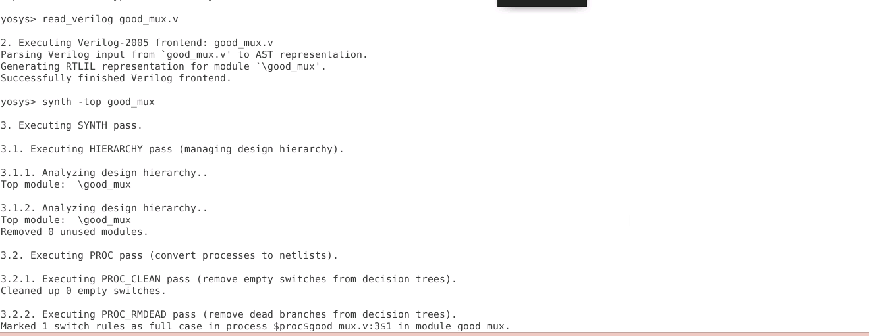

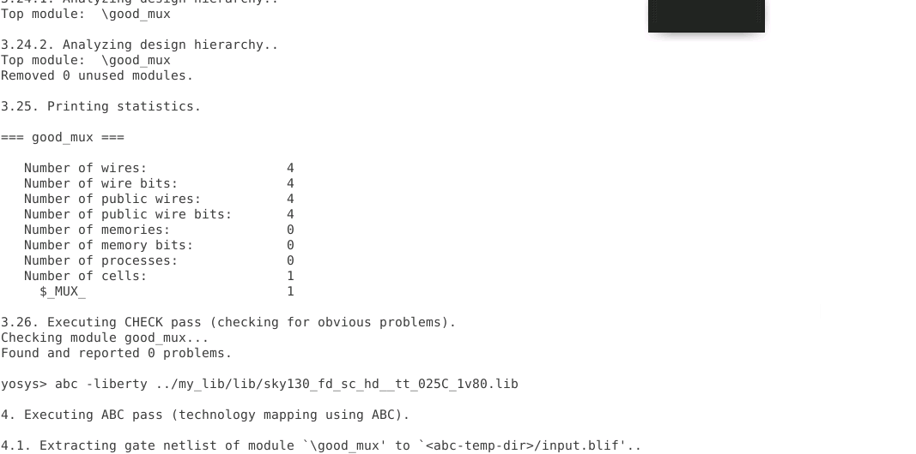

Below screenshot is after show command.

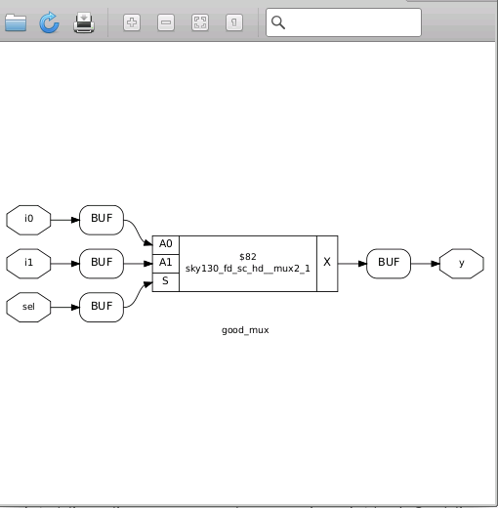

Below screenshot is after commands : write_verilog -noattr good_mux_netlist.v

!vim good mux_netlist.v

